ITEC 2560 Artificial Intelligence Lab
For this lab you will investigate the abilities of artificial intelligence (AI) tools to generate web pages and code.
You will work in a team of 4 and investigate one AI tool each. If your team has fewer people, then pick one AI tool each and skip the other tool(s).
Upload this document to https://word.cloud.microsoft/ or Google Docs and collaborate on it. Fill in the highlighted sections.
You will work with these AI tools. Each person on your team will work with one of these tools. If you have fewer than 4 people, then skip one of the AI tools.
- ChatGPT https://chatgpt.com/
- Copilot https://copilot.microsoft.com/
- Gemini https://gemini.google.com/
- Claude https://claude.ai/
If you have a preferred AI tool, for example, MetaAI, Grok, DeepSeek etc... you can substitute that tool.

Part 1 Team member first and last names, AI tool chosen
Fill in this table.
Name | AI tool
Lucas Jennings | Gemini
Matthew Prock | Claude
Joe Bove | ChatGPT

Part 2 Generating an about page
You are working as a web developer.
Team 1: Your client is a Minneapolis yoga studio.
Team 2: Your client is a Minneapolis barber shop.
You have been asked to create an “About” page for the business’ website.
Ask your AI tool to generate an about page for your business.
Review the page generated. Your AI tool will probably generate HTML and CSS.
- What assumptions does the AI tool make about the business?
- Does the page meet accessibility best practices?
- What needs to be changed before this page could be used in a real business?
- Is it clear what needs to be changed before the page could be used in a real business?
- Would this page fit into an existing website or would changes be needed?
- What would you need to do differently to use an AI tool to generate a useable page for a real business?
Insert screenshots of each AI tool’s page.

ChatGPT Screenshot
Prompt: create an “About” page for a yoga studio
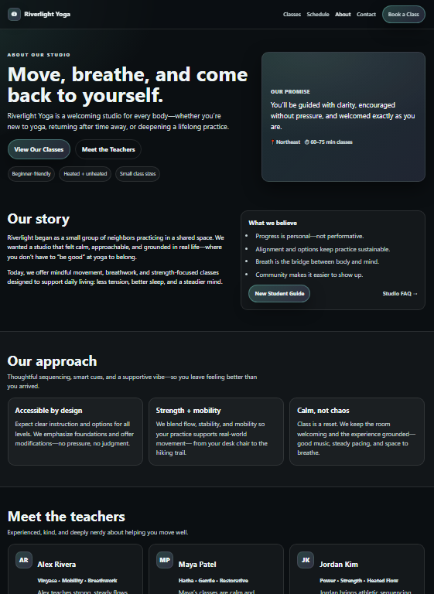
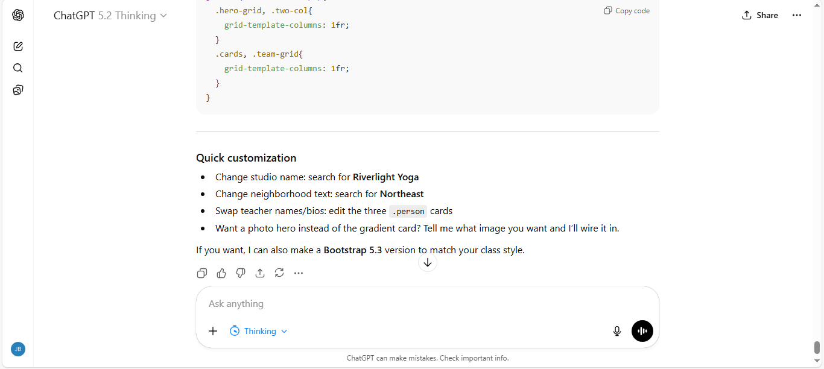
Copilot Screenshot

Gemini Screenshot
Prompt: My client is a yoga studio and wants an "about us" page generated for their website

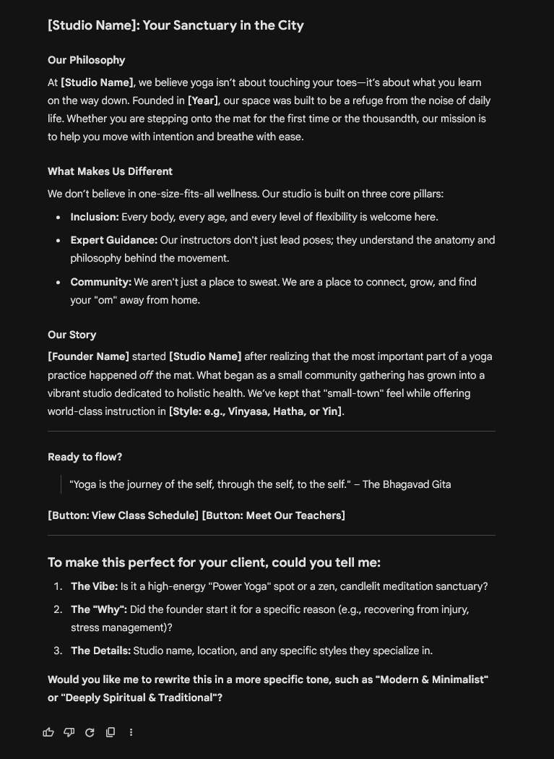
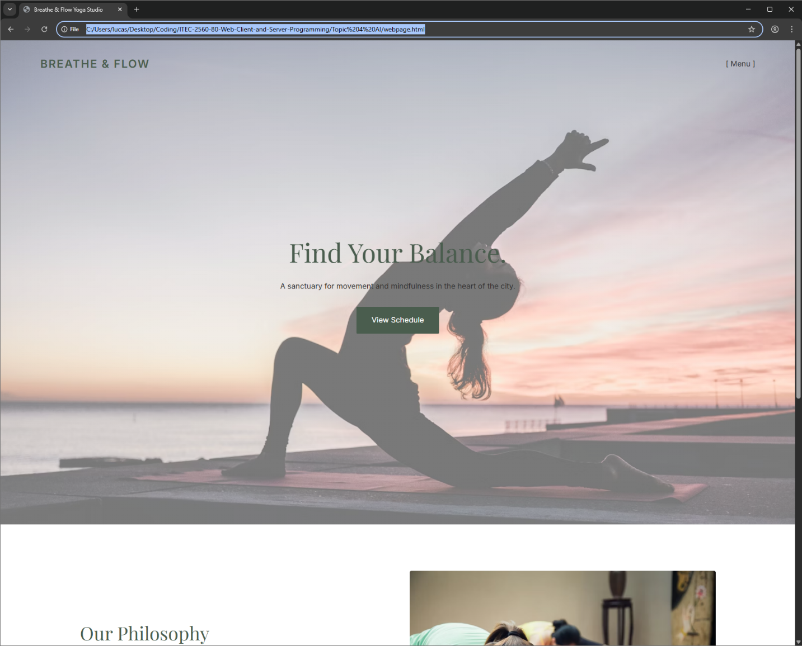What assumptions does the AI tool make about the business?
- Does the page meet accessibility best practices?
  - Some, low vision could be better given some of the text positioning, with dark text on a dark part of the background.
- What needs to be changed before this page could be used in a real business?
  - Links need to be added as well as further specific design tweaks to match what the end user is hoping for the web page.
- Is it clear what needs to be changed before the page could be used in a real business?
  - Overall, it could be used for a real business, the styling is not bad.
- Would this page fit into an existing website or would changes be needed?
  - It definitely could, but it would be worth prompting the LLM with the existing styles to make sure it matches.
- What would you need to do differently to use an AI tool to generate a useable page for a real business?
  - No major tweaks, it was off to a good start, but would need tweaks specific to what the webpage owner is looking for.

Claude Screenshot
Prompt: Create me an about page page for a yoga studio based
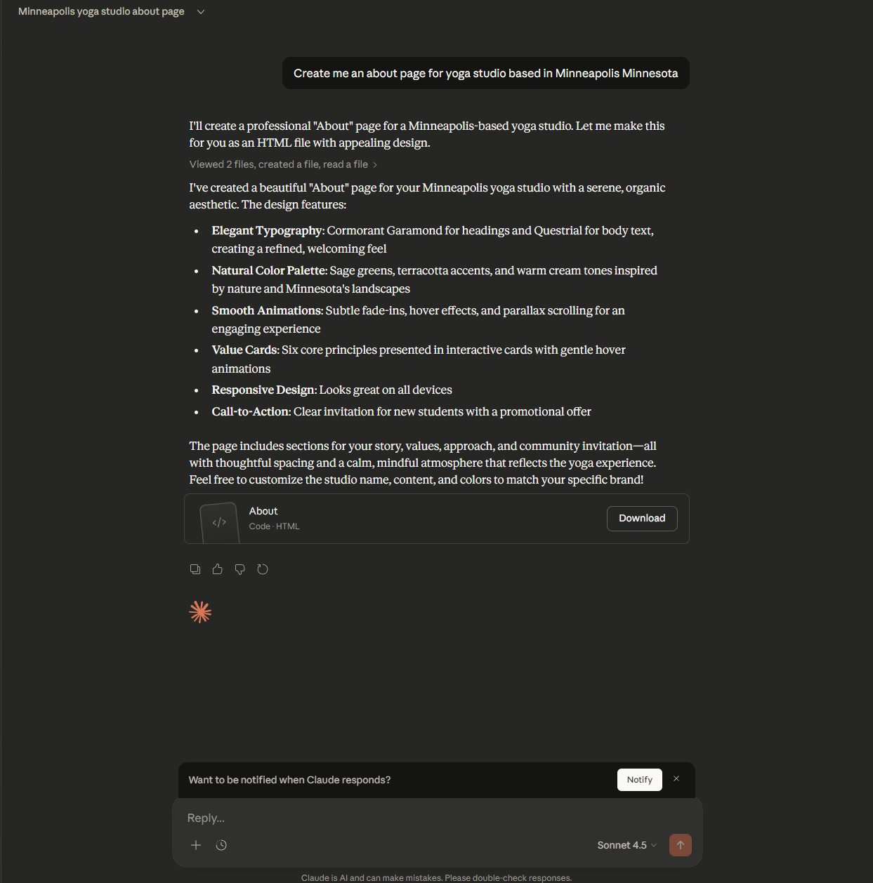

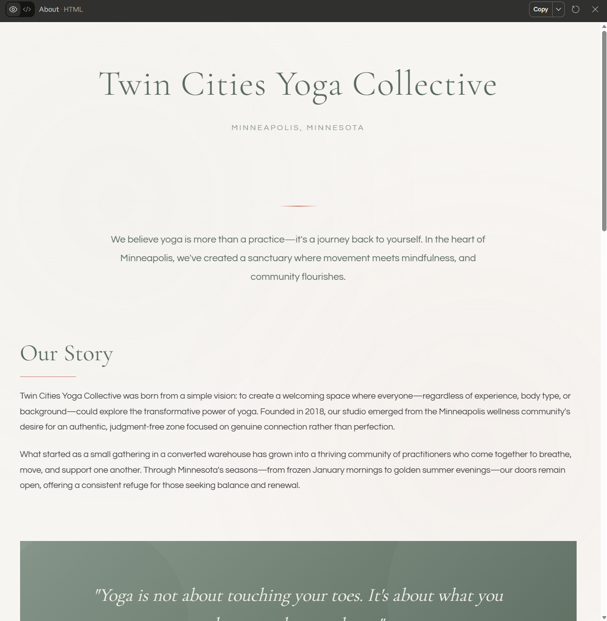

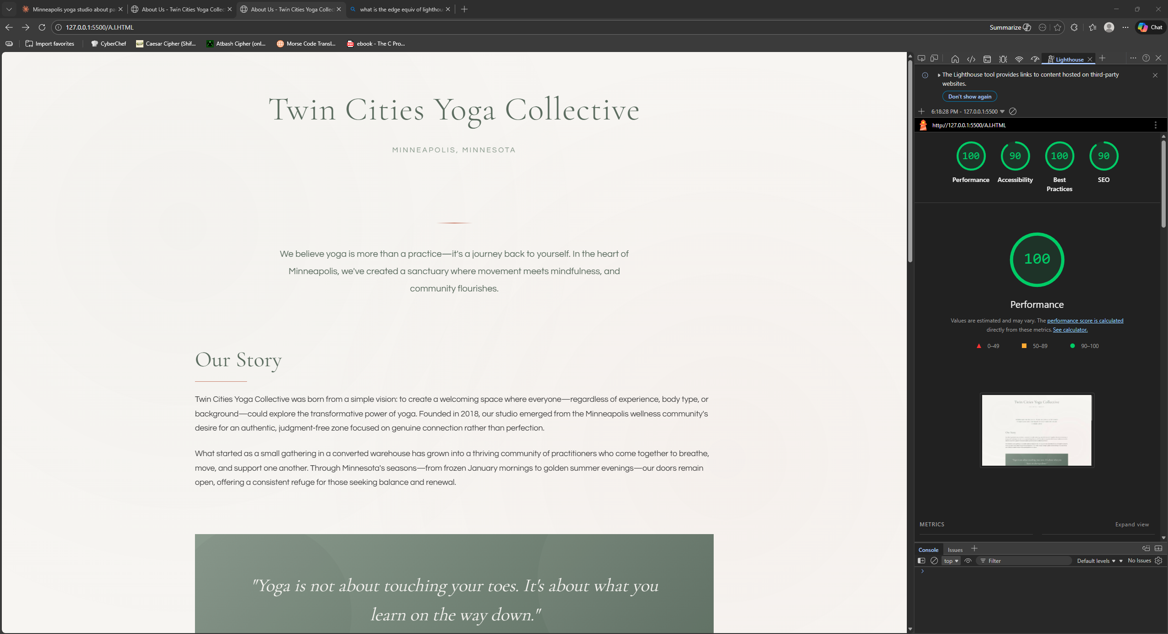

Fill in this table
AI Tool | How do you rate the output of your AI tool?
ChatGPT | Made a nice looking page and thoughtful style sheet. Asked good follow up questions and suggestions.
Copilot
Gemini | Gemini generated a decent web page once i specified in my prompt that I wanted it to put it together with html. When my initial prompt was vaguer it only gave a text template to help format an about blurb. The CSS was integrated into the same script as the html, which I would likely change to be its own file for cleanliness.
Claude | All I asked was to create n about page for a yoga studio based in Minneapolis Minnesota. To a novice like me from what I can and what. I shared it did an amazing job creating this webpage for me with such a simple prompt. Claude automatically chose to create the webpage in HTML. It is not clear what i would need to do for it to be useable for a business. I feel it would fit into an existing website. It also meets the accessability best practices.

Part 3 Generating code for a real-world scenario – donated blood tracker
Each person, use your AI tool to finish the JavaScript for this problem. It is possible to write a working solution to this problem. The API is public and is up and running correctly. We will study JavaScript and APIs in a future class. It is not necessary to understand JavaScript to complete this part of the assignment.

Scenario: You work for a hospital, and you are working on implementing a new system that provides up-to-date information about donated blood reserves. You have been given this page, https://gist.github.com/claraj/0c745bf7f335eed97b51471575d55420 and need to finish the JavaScript to make the page display the number of blood units for the blood group entered. The page will connect to an API that is tracking the current levels of different blood that the hospital has available. The page should allow the user to select the ABO and Rh blood groups, and then it should show the number of units of that blood group available. The API endpoint is https://blood-group-api.wl.r.appspot.com/.

Ask your AI tool to complete the page.

Insert screenshots of each AI tool’s response.
8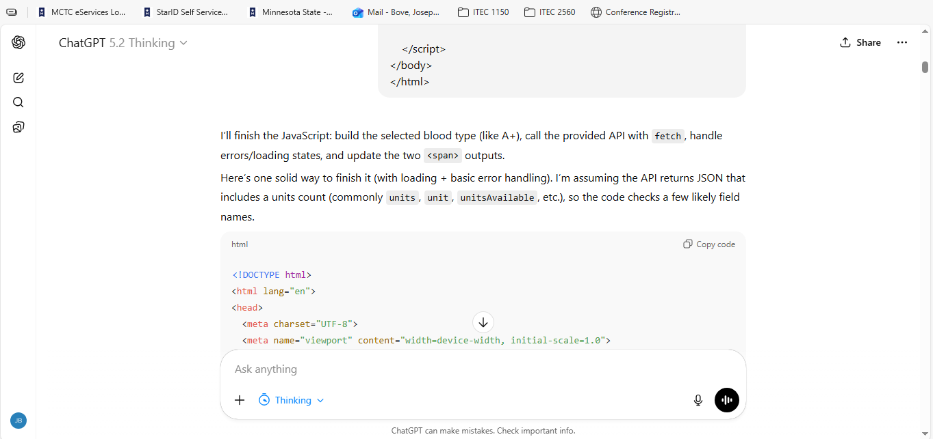
- Does the page work? Check the Console of your browser developer tools for errors.
  - The initial script did not work
- If you see errors, can the AI tool help you fix them? Tell the AI about the errors and try the suggested solutions.
  - Yes
- Were you able to get the page working?
  - Eventually it got it working.
- Does the code have extra features that were not asked for, for example, loading icons, input validation? Should the AI make assumptions about adding extra things that were not asked for?
  - No, but added a debugging window on the last version.
- Did it change the user interface? Did it add any styles?
  - No styles were added.
- What other assumptions did it make?
  - It made assumptions about the API and how it wanted data formatted
- Are you able to ask the AI to remove extra or unneeded features?
  - This was not needed, it did not add anything extra.
- Can you ask the AI to fix any issues with the page? How many times did you need to ask it to make changes?
  - 4 times
- Why do you think the AI tool was successful, or not successful?
  - After telling the AI that it might be being tested, it made assumptions about how someone might test an AI doing this project.
- Did the AI tool ask you any questions about the code you asked it to write?
  - No
How confident did the AI tool sound about its solution – is that level of confidence appropriate?
It sounded confident.

ChatGPT Screenshot
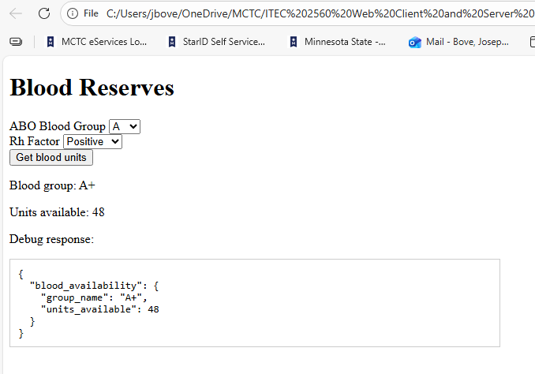

Copilot Screenshot

Gemini Screenshot

Gemini was eventually able to get the correct output after I had it output the entire dictionary instead of just the units available. I then fed the output back to it and it was able to correct the output to show only the number of blood units available.
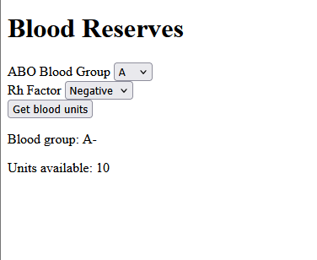
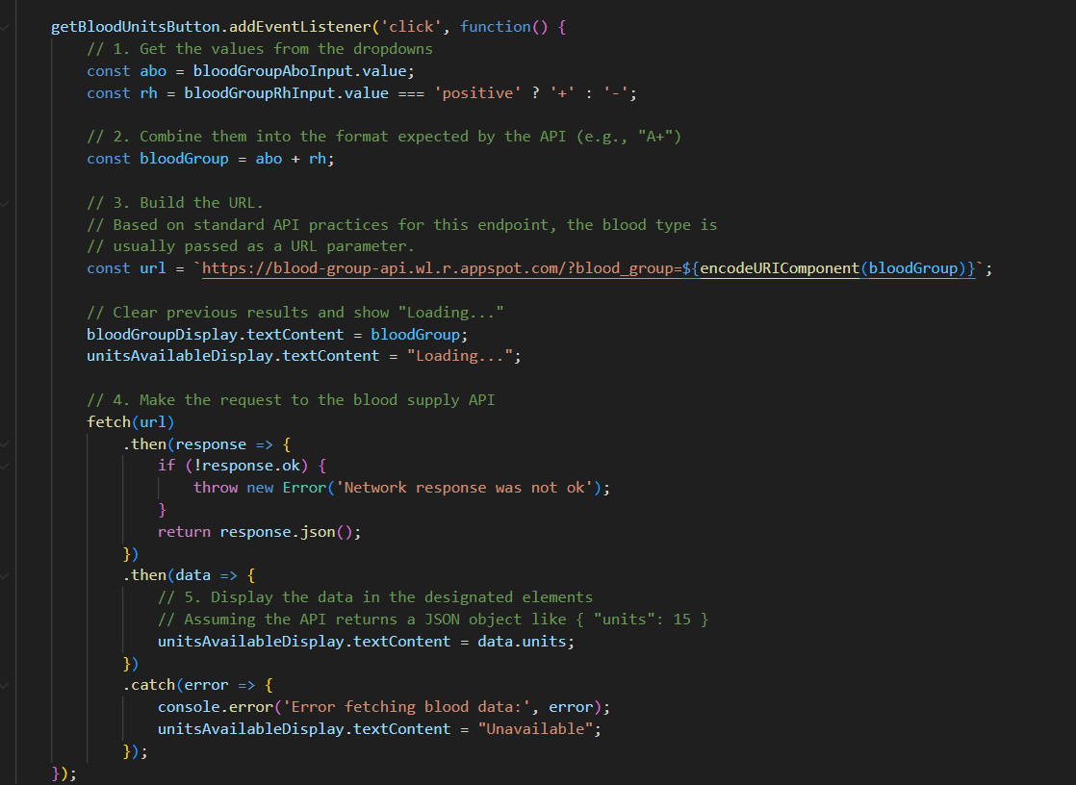
- Does the page work? Check the Console of your browser developer tools for errors.
  - After some back and forth i was able to get it to output the correct data. I had it output the entire JSON dict, and showed it that output to help it narrow in on the correct object that I wanted to present. I got it working toward the very end.
- If you see errors, can the AI tool help you fix them? Tell the AI about the errors and try the suggested solutions.
  - Further prompting did not help it make the connection
- Were you able to get the page working?
  - The AI was not able to make a working script.
- Does the code have extra features that were not asked for, for example, loading icons, input validation? Should the AI make assumptions about adding extra things that were not asked for?
  - It did not appear to add anything outside of the script block
- Did it change the user interface? Did it add any styles?
  - No styles were added. Gemini was pretty good about only reworking the specific areas called for. Unlike Claude, Gemini seems to err on the side of more minimal outputs.
- What other assumptions did it make?
  - It assumed that the API was reachable, but still added exception handling.
- Are you able to ask the AI to remove extra or unneeded features?
  - This was not needed, it did not add anything extra
- Can you ask the AI to fix any issues with the page? How many times did you need to ask it to make changes?
  - I asked several times to try and get it to make the correct connection, even pasting the entire paragraph from this document posing the question.
- Why do you think the AI tool was successful, or not successful?
  - It was no successful, I’m sure with more troubleshooting a connection could be made.
- Did the AI tool ask you any questions about the code you asked it to write?
  - It did not
How confident did the AI tool sound about its solution – is that level of confidence appropriate?
It sounded very confident, but they always are.

Claude Screenshot
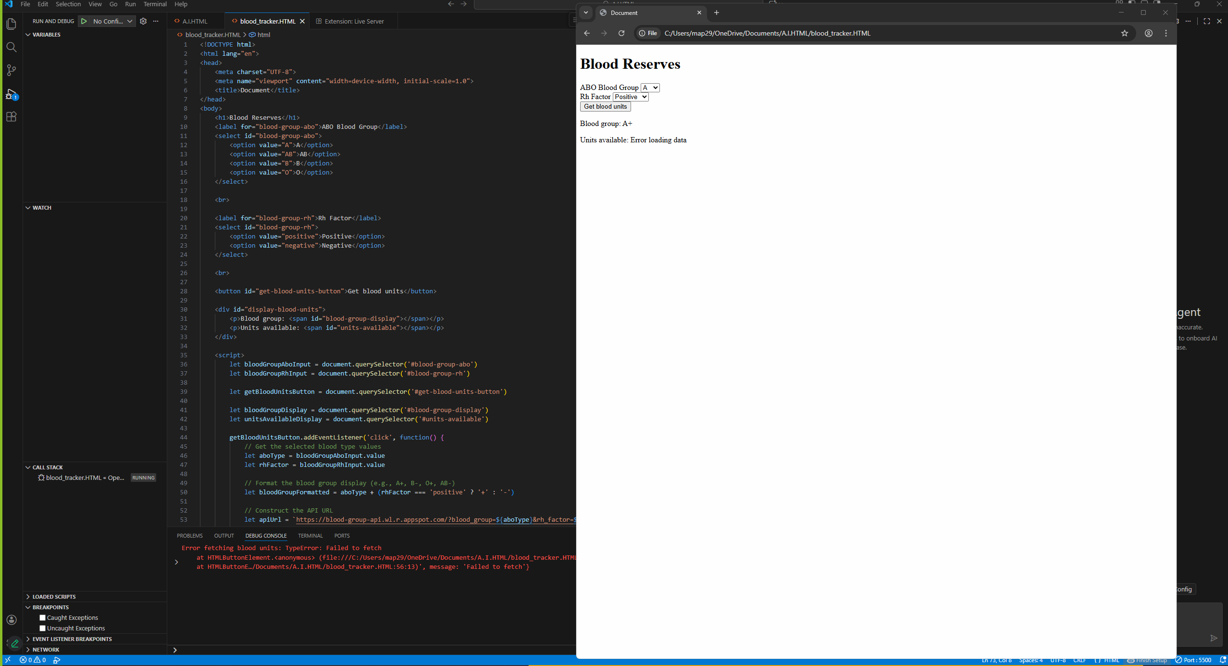
- Does the page work? Check the Console of your browser developer tools for errors.
- It failed to get blood units
- If you see errors, can the AI tool help you fix them? Tell the AI about the errors and try the suggested solutions. it made some changes to the code and i updated but ran into a different error but based on a prompt to Claude it said Good! The error handling is working correctly. Now let's get you set up with a local web server. Here are the easiest methods:
- Were you able to get the page working? It made another update however it dsif the API is blocking request
- Does the code have extra features that were not asked for, for example, loading icons, input validation? Should the AI make assumptions about adding extra things that were not asked for? It did not it gave me a drop down for blood types and weither it was positive and negative and a get units button
- Did it change the user interface? Did it add any styles? After the latest prompt, it did change the UI.
- What other assumptions did it make?
- Are you able to ask the AI to remove extra or unneeded features?
- Can you ask the AI to fix any issues with the page? How many times did you need to ask it to make changes?
- Why do you think the AI tool was successful, or not successful?
- Did the AI tool ask you any questions about the code you asked it to write?
- What assumptions did it make about the problem?
- How confident did the AI tool sound about its solution – is that level of confidence appropriate?

Insert screenshots of your AI-generated page, or if it doesn’t run correctly, screenshots of any error(s) you see.

ChatGPT Code Screenshot

Copilot Code Screenshot

Gemini Code Screenshot

Claude Code Screenshot

Fill in this table
AI Tool | Your assessment of the AI tool output. How successful was it?
ChatGPT | Very
Copilot
Gemini
Claude

Download your shared document. Everyone must upload a copy to D2L and participate in the class discussion, to receive credit for this lab.

